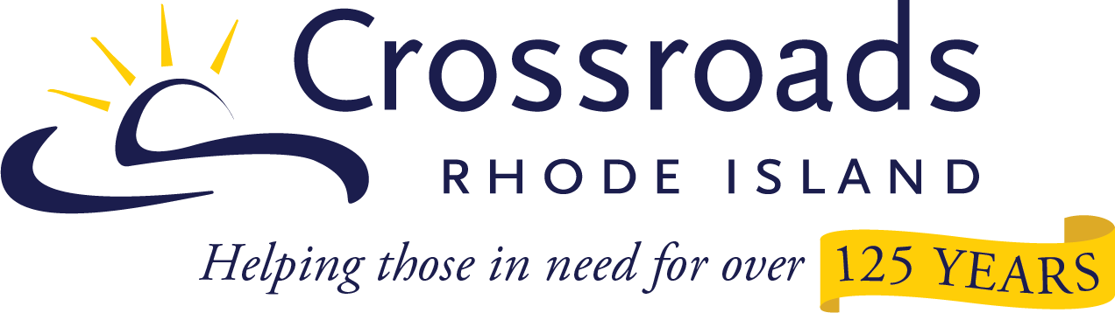

Host a Fundraiser - Guidelines
Thank you for your interest in hosting a fundraiser in benefit to Crossroads Rhode Island. We rely on individuals and organizations to help raise important funds and spread awareness for the benefit of the clients we serve. What follows are some guidelines that will help you be successful in your fundraising efforts. If you have any questions, please contact Ric Wild in the Marketing & Development Office at rwild@crossroadsri.org or 401-277-4331.
- Host a Fundraiser activities should be consistent with Crossroads’ mission and values.
- Before hosting a fundraiser, we respectfully request that you contact Crossroads Rhode Island. Please submit an application here. We’ll follow up shortly after we receive your completed application.
- All promotional materials should clearly state the fundraiser is sponsored by you or your organization with proceeds benefitting Crossroads. For example, an event should not be referred to as a “Crossroads Bake Sale.” Instead, it should be advertised as “ABC Company Bake Sale to Benefit Crossroads.”
- Funds may be received using Crossroads’ website, Facebook, MobileCause, or GoFundMe (we can help you figure out which giving platform will be most appropriate for your fundraiser). Checks should be made payable to: Crossroads Rhode Island.
- Fundraisers will receive a Letter of Support from Crossroads Rhode Island to help your event be as successful as possible.
- Crossroads Rhode Island can share a logo to support advertising or other promotional efforts.
- Fundraisers are responsible for obtaining all relevant permits, licenses, and insurance coverages.
- If your fundraiser involves raffles, drawings, and other games of chance, you may need to consult federal and state laws governing these activities. If permits and other forms are needed, they will be your responsibility to obtain.
- Crossroads Rhode Island assumes no legal or financial liability associated with Host a Fundraiser events and activities.
- Crossroads does not pay for advertising or any other costs associated with hosted fundraising.
- No bank accounts or holding accounts of any kind can be established under Crossroads' name.
- Funds provided will go to support areas within Crossroads with the greatest need, and donors will receive a formal acknowledgement letter and applicable tax receipt.

