- Direct Support Professional Job Opportunities!  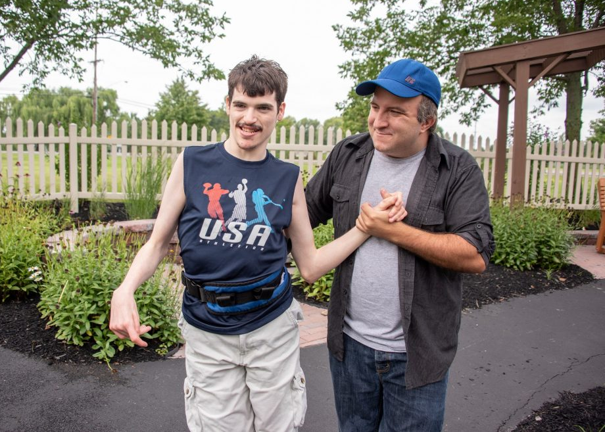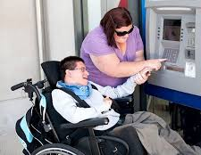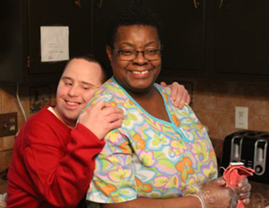  - Want to jump start your career and make a difference in someone’s life?  As a Direct Support Professional (DSP) you would be helping people with disabilities live their best life by supporting them in their everyday living activities, in their home and community.  - Earn $11-$14/hour  - On-the-job paid training  - Potential for career advancement  - Job security (DSPs are in high demand)  - Flexible hours  - Requirements:  - Background Check  - Driver’s License (preferred, but not required)  - High School Diploma/GED (preferred, but not required)  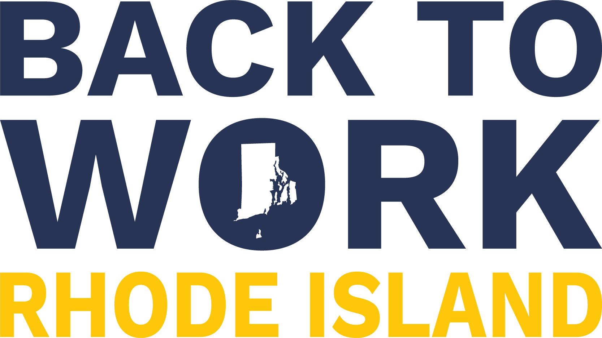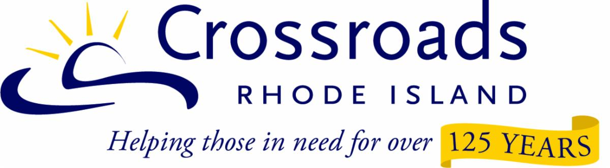 | Want a rewarding job earning $11-$18/hour?  We are working with 5 employers who are hiring!  We provide support to help you get the job and keep it once you are employed!  All training is completed on the job!  Get hired as a Direct Support Professional now!  For more info CONTACT  Leanne Ovalles  401-277-4369  lovalles@crossroadsri.org  Crossroads RI  160 Broad St  Providence, RI 02903

